A000-Asia-Oxus-Ganhara-Buddha- fearless mudra

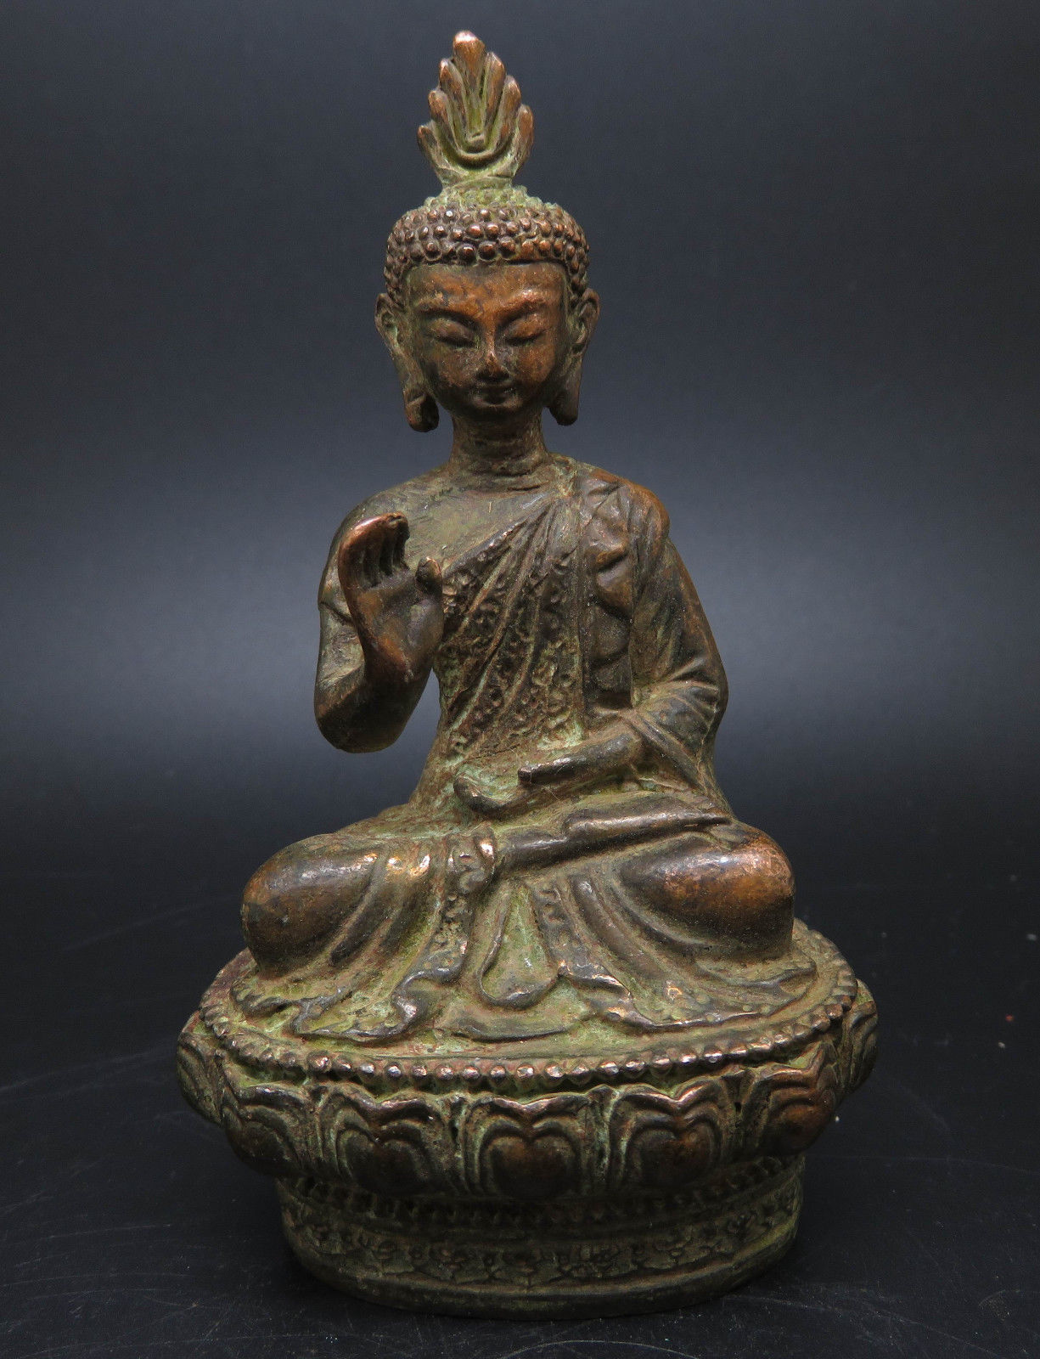 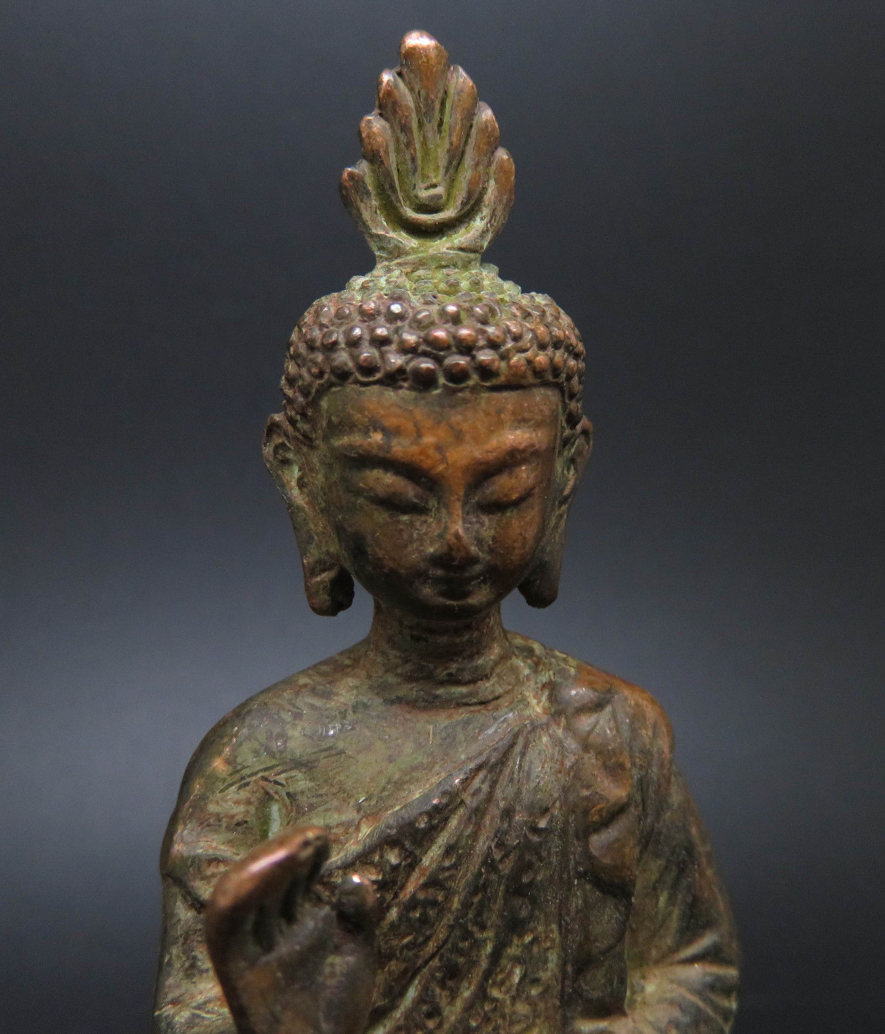 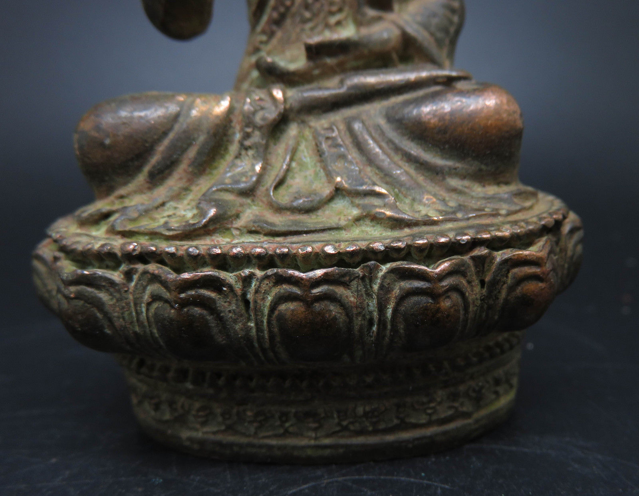 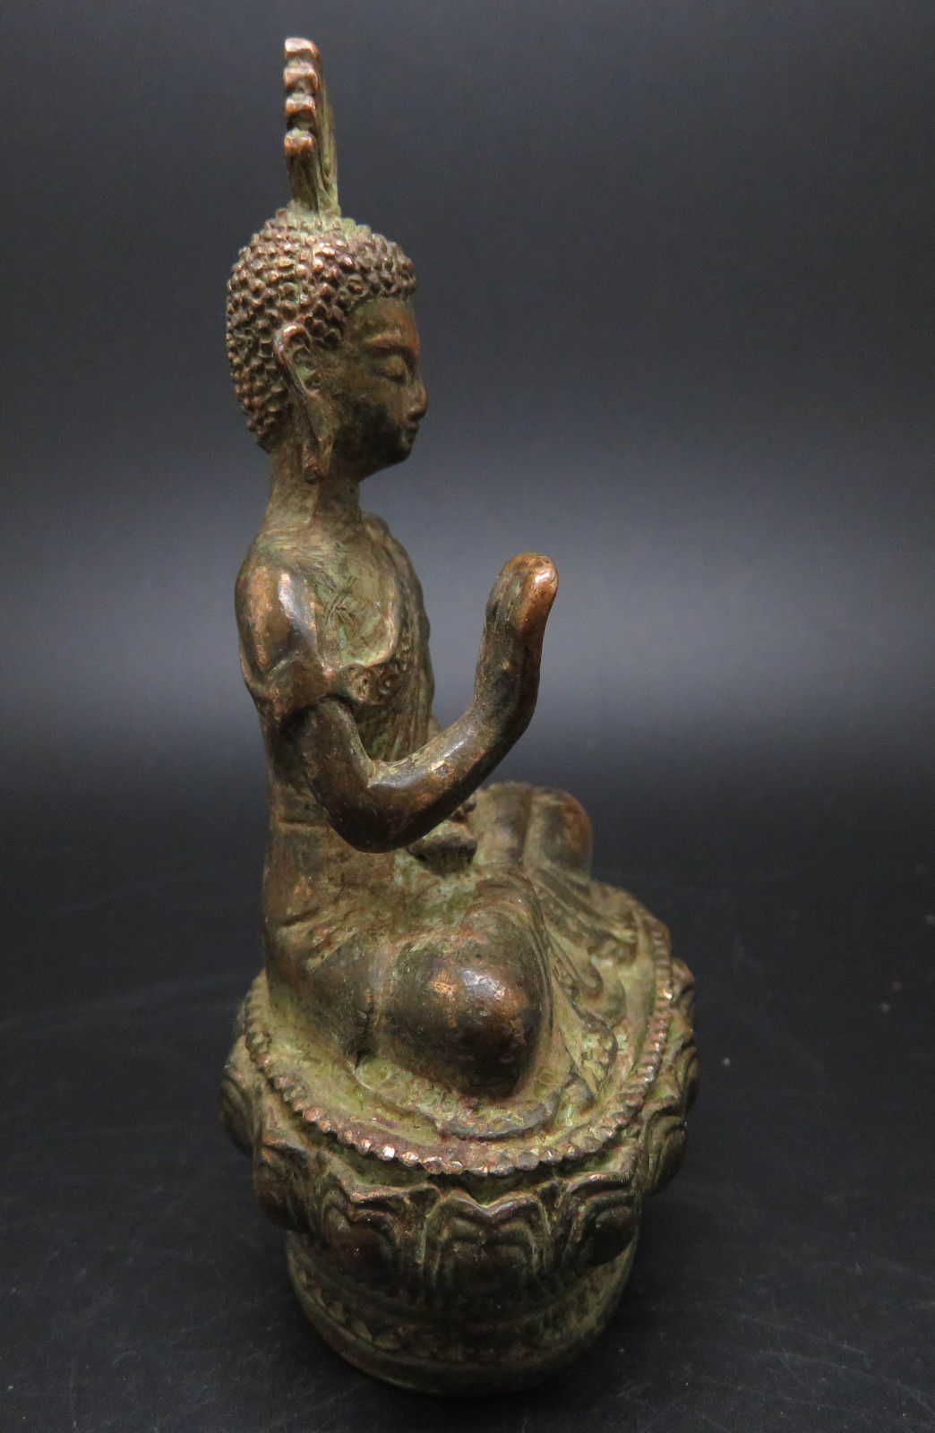 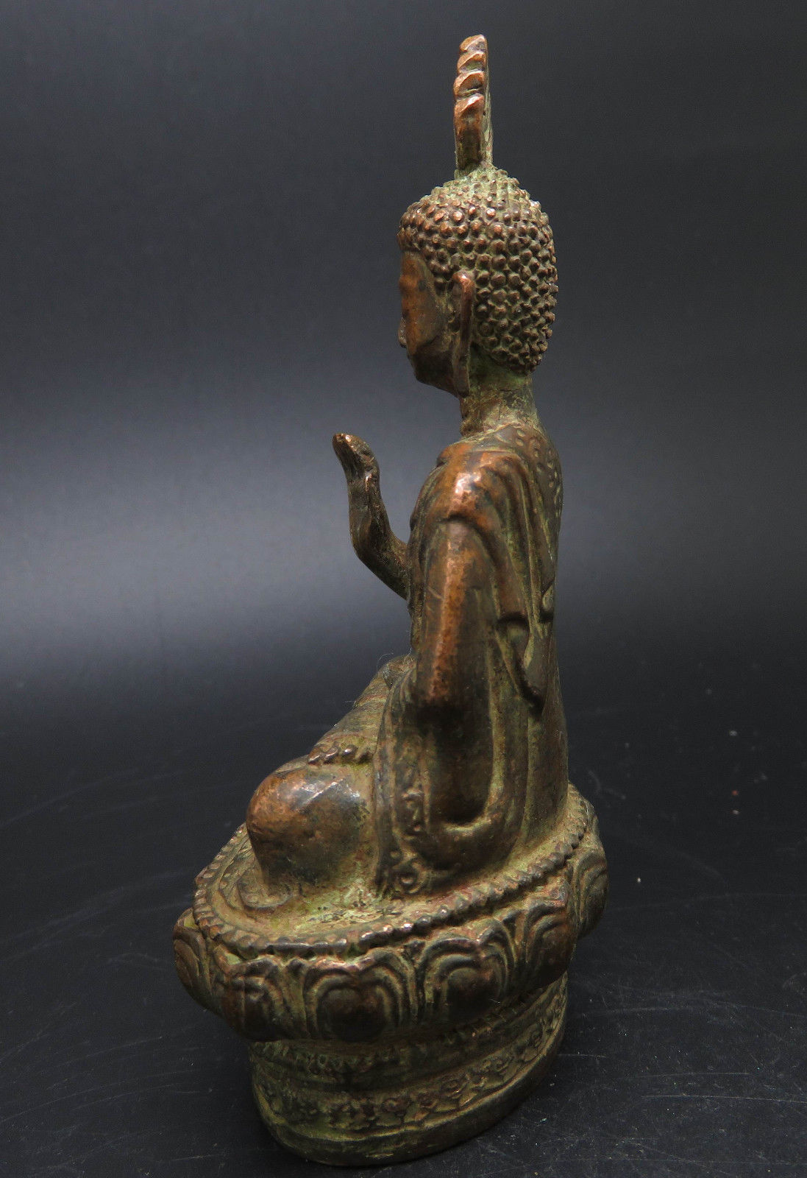 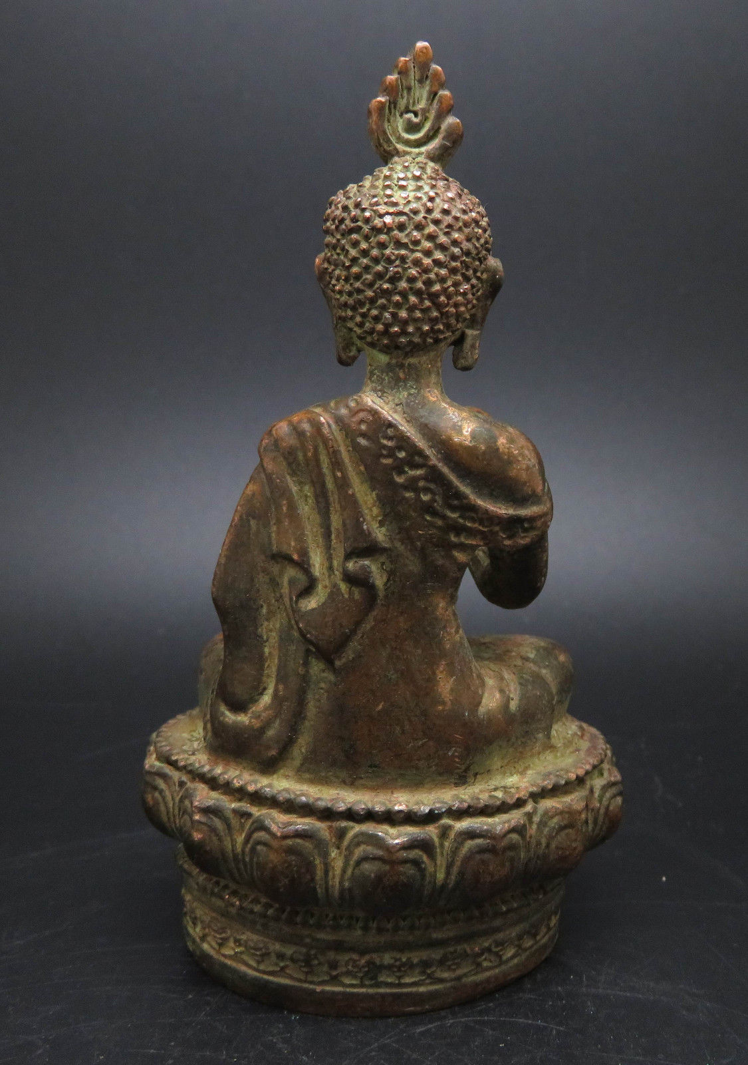

|  |  |  |
| --- | --- | --- |
| "fearless mudra". (abhaya) This gesture is also called "Gesture of Fearlessness" or "blessing" or "fearless mudra". Generally, this position is shown with the palms(s) facing outward and the fingers extended upwards. The arm is elevated and slightly bent. You can find abhayamudrâ sometimes also as a left-hand gesture. This mudra is characteristic of Buddha Shakyamuni and Dhyani Buddha Amogasiddhi. | |  | | --- | | http://www.buddhas-online.com/mudras2/M1.gif | |

97*55*42mm